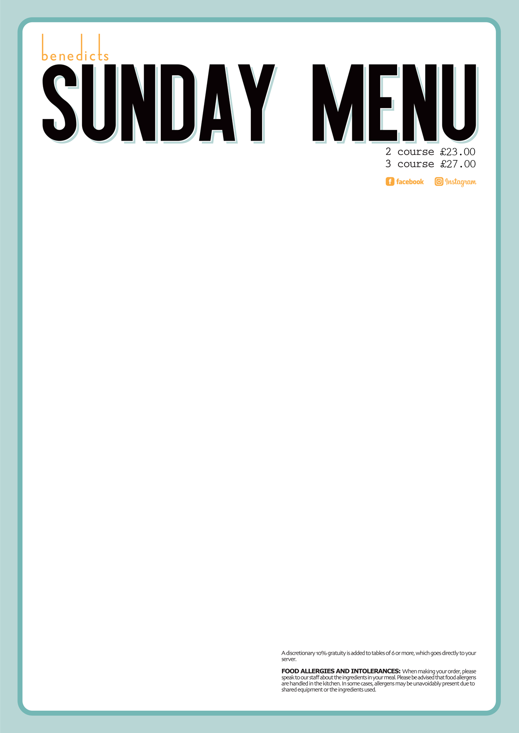

Cream of Vegetable Soup  Wheaten Bread and Butter.  Seafood Chowder  Catch of the Day, Peas, Potatoes, Herbs, White Wine Cream, Garlic Bread.  Bang Bang Cauliflower  Hot Sauce, Dressed Leaves  MAINS | 6.50  8.00  7.00 | Baked Four Cheese Garlic Bread  Rocket and Garlic Mayo.  Salt ‘n’ Chilli Chicken  Asian Slaw, Basil & Coriander Dressing, Honey & Chilli. | 7.00  8.00
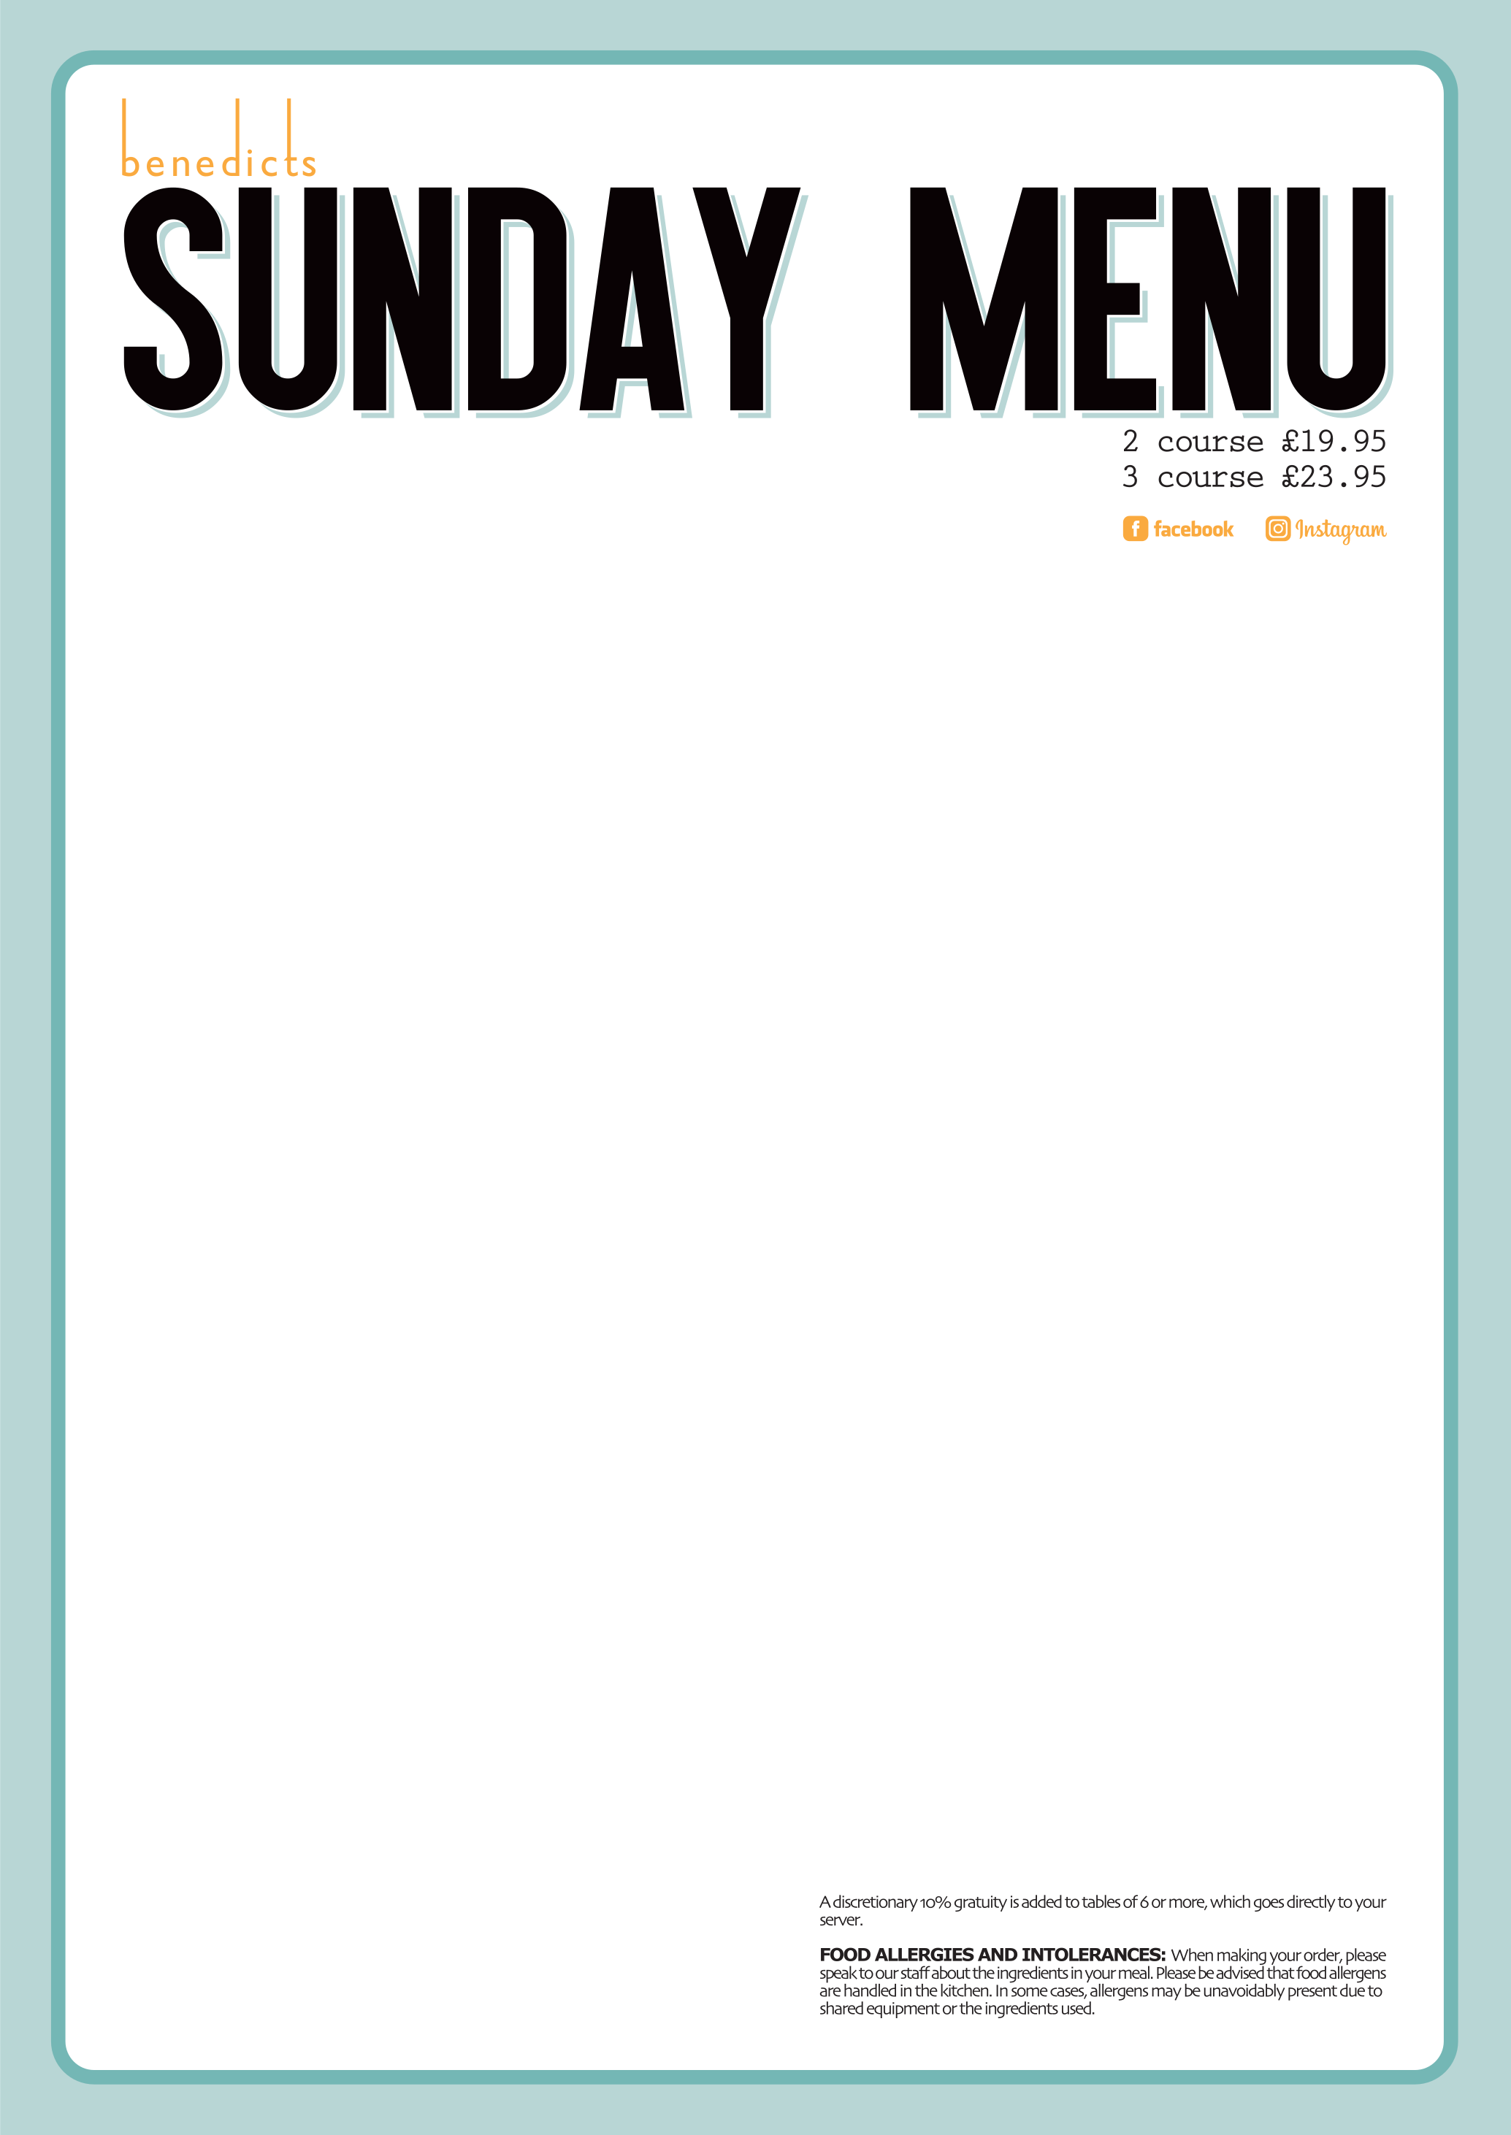
STARTERS
Peppered Chicken Stack  Peppered Chicken, Champ, Tobacco Onions, Pepper Sauce.  Salt n Chilli Chicken  Asian Slaw, Basil and Coriander Dressing, Honey and Chilli, Skinny Fries.  Pork and Leek Sausages  Mash and Onion Gravy.  DESSERTS  Sticky Toffee Pudding  Toffee Sauce, Vanilla Ice Cream.  Chocolate and Coconut Tart  Chocolate Ice Cream, Berry Puree.  Cheesecake of the Day  Chantilly Cream. | 17.00  17.00  17.00  7.00  7.00  7.00 | Roast Turkey and Ham  Roasties, Mash, Root Vegetables and Sunday Gravy.  Slow Cooked Roast Beef  Roasties, Mash, Root Vegetables and Sunday Gravy.  Roast Leg of Lamb  Roasties, Mash, Root Vegetables and Sunday Gravy.  Honey Roast Gammon  Roasties, Mash, Root Vegetables and Sunday Gravy.  10oz Sirloin Steak  Chunky Chips, Tomato, Mushroom & Peppered Sauce.  (£10 Supplement Charge)  8oz Fillet Steak  Chunky Chips, Tomato, Mushroom & Peppered Sauce. (£14 Supplement charge)  Keenan’s Seabass Fillet  Herb Crushed Potatoes, Garlic & Lemon Butter, Greens.  Keenan’s Fish and Chips  Battered Haddock, Curry Sauce, Triple Cooked Chips.  Keenan’s Skin On Smoked Cod  Champ, Bacon and Leek & White Wine Cream. | 17.00  17.50  17.50  17.00  28.00  32.00  17.00  17.00  18.50
Fried Chicken Wings 8.00
Sesame, Pickled Veg, BBQ Sauce or Franks Hot Sauce

